**Name:** Pranav Dilip Hingankar

**Batch:** T6

**PRN:** 2020BTECS00040

Assignment 8 - Software testing using tools

1. What are the prerequisites for installing the TestLink tool.
   1. Web Server − TestLink supports Apache 2.2.2.1. However, it can work with any latest web server software. TestLink only uses .php file. Configure the web server with .php extension only.
   2. PHP − The web server should support PHP. It can be installed as CGI or any other integration technology. It is recommended to use 5.3.8 PHP version.
   3. Mandatory PHP Extensions − Extensions for RDBMS are mysqli, pgsql, oci8, sqlsrv. Mbstring is required for Unicode – UTF-8 support.
   4. Optional Extensions − Curl, GD, Fileinfo
   5. Database − TestLink requires database to store its data. MySQL (5.5.16) is recommended.
   6. FileZilla FTP Server − FileZilla FTP Server 0.9.39 is required to install XAMPP as optional.
2. Install TestLink tool on your machine (Provide screen shots for successful installation and login)

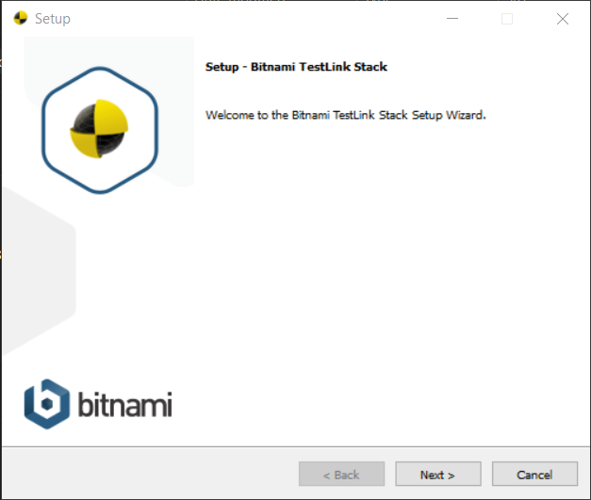

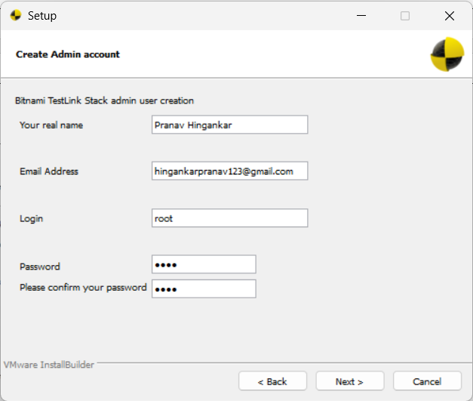

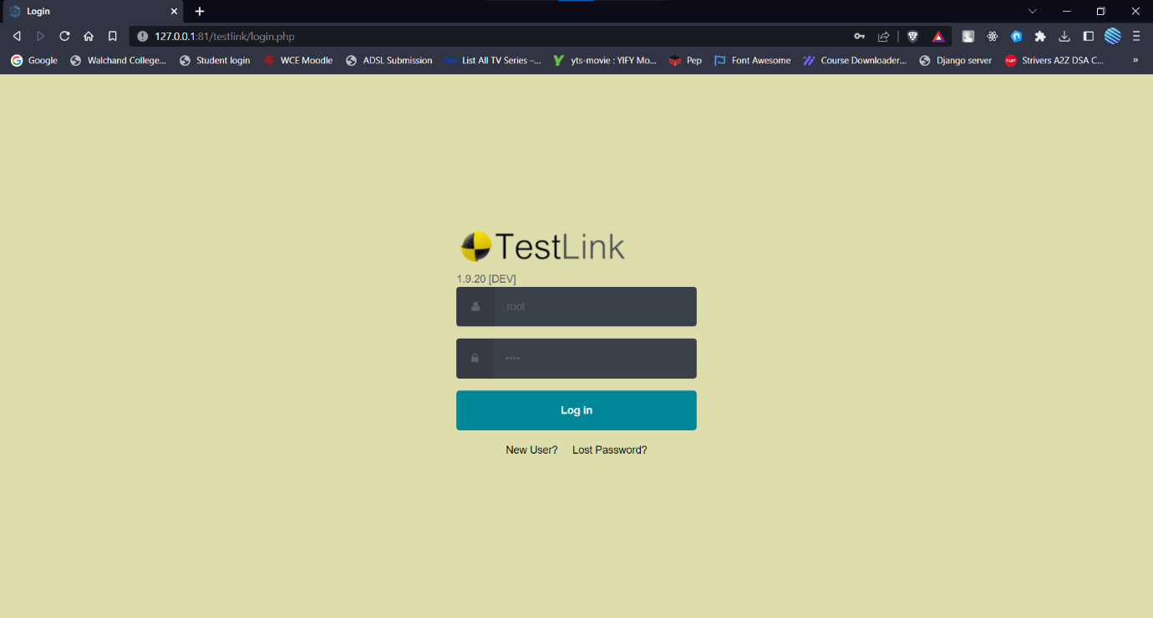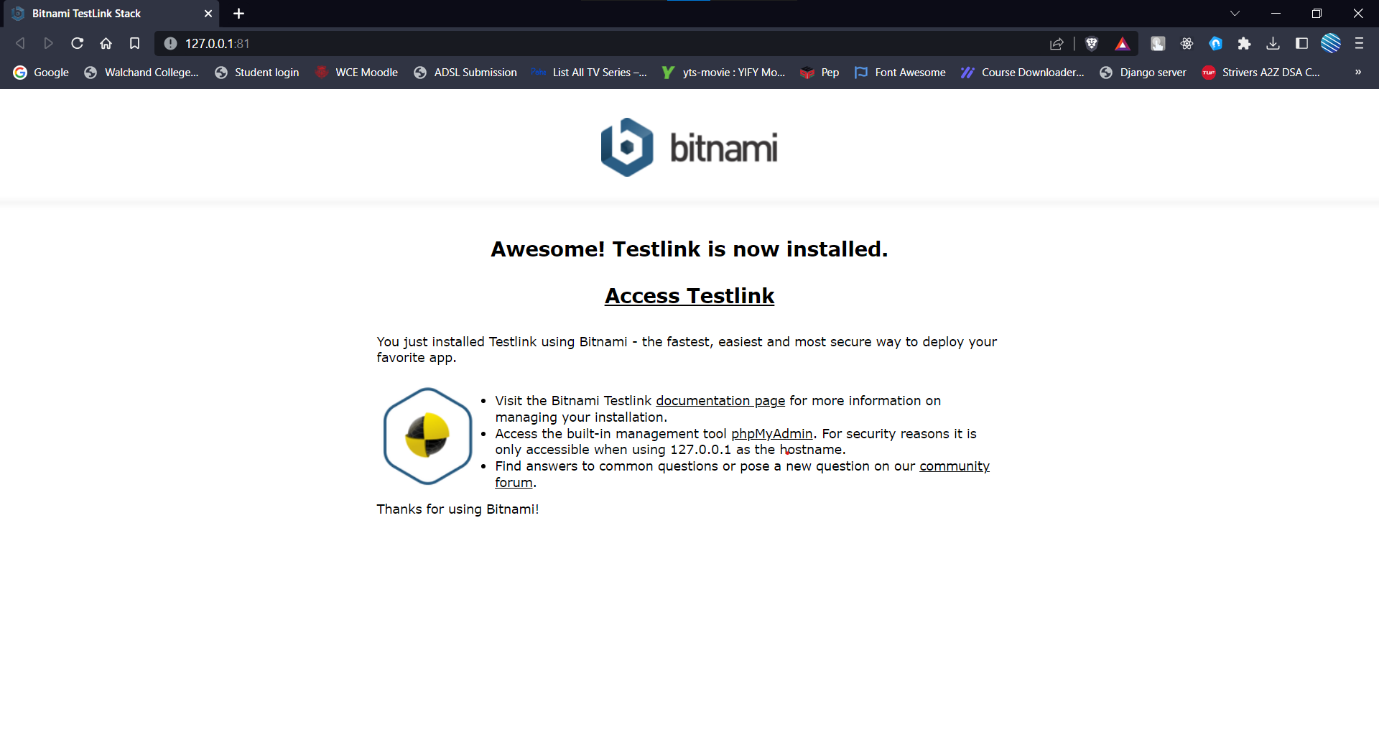

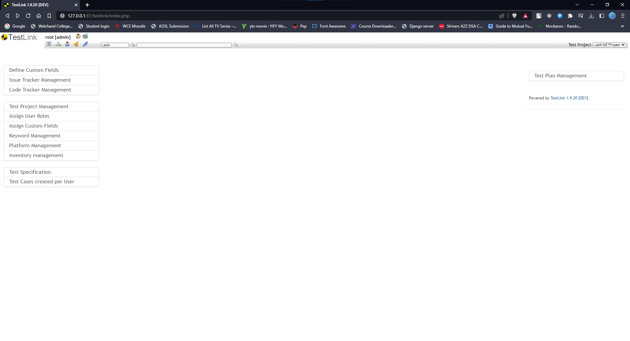

1. Using TestLink tool create multiple test cases (at least 10) on any application/project that you have implemented.

Perform below tasks

1. Create New test project as SETProject

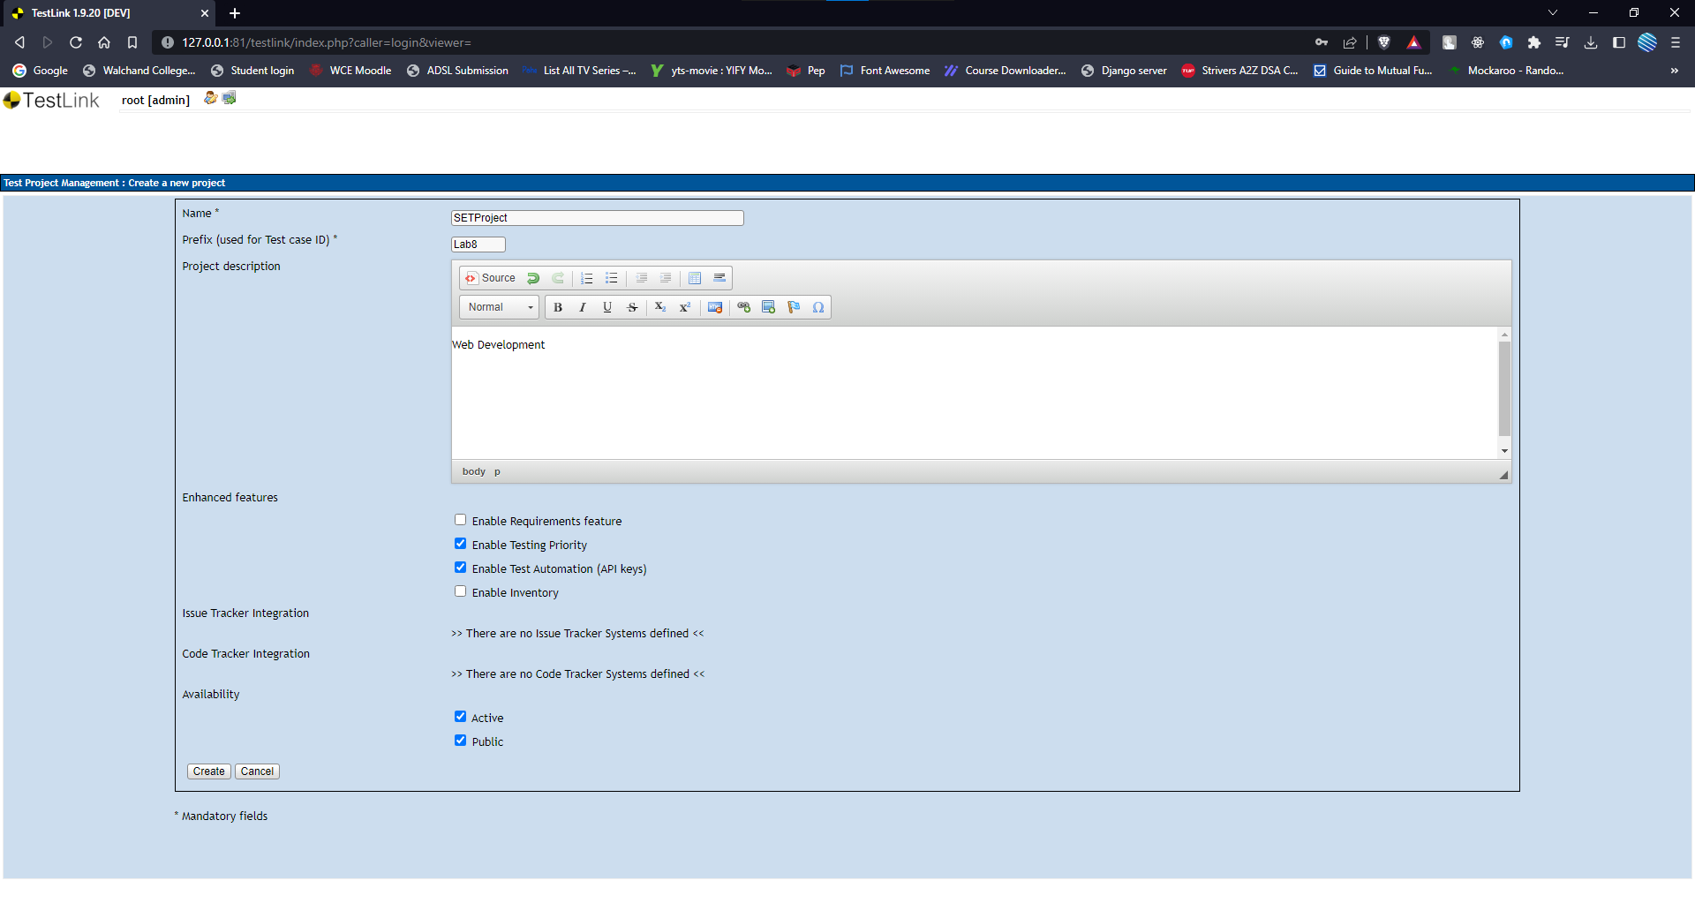

1. Create a test plan as SETProjectTestPlan

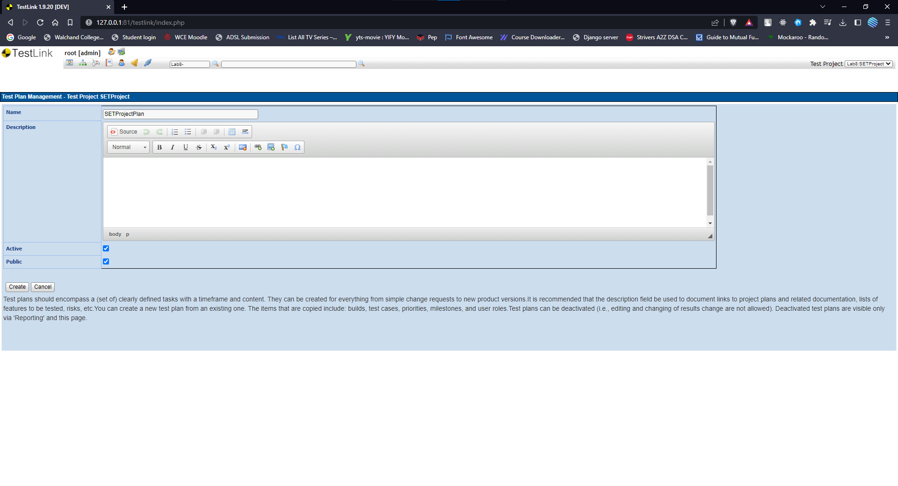

1. Create a build as SETProjectBuild

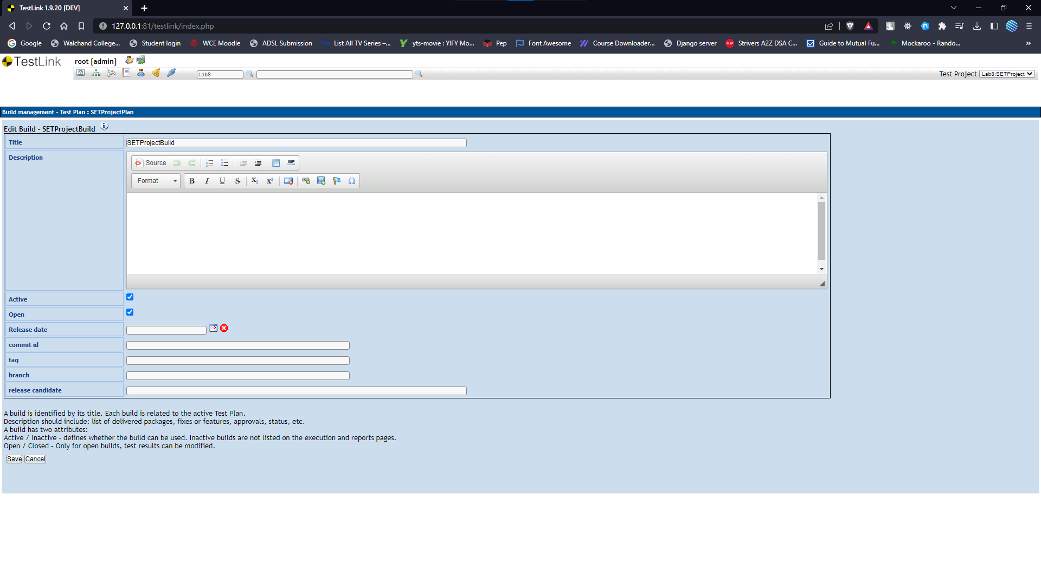

1. Create test suite as Test Suite 1 under SETProject

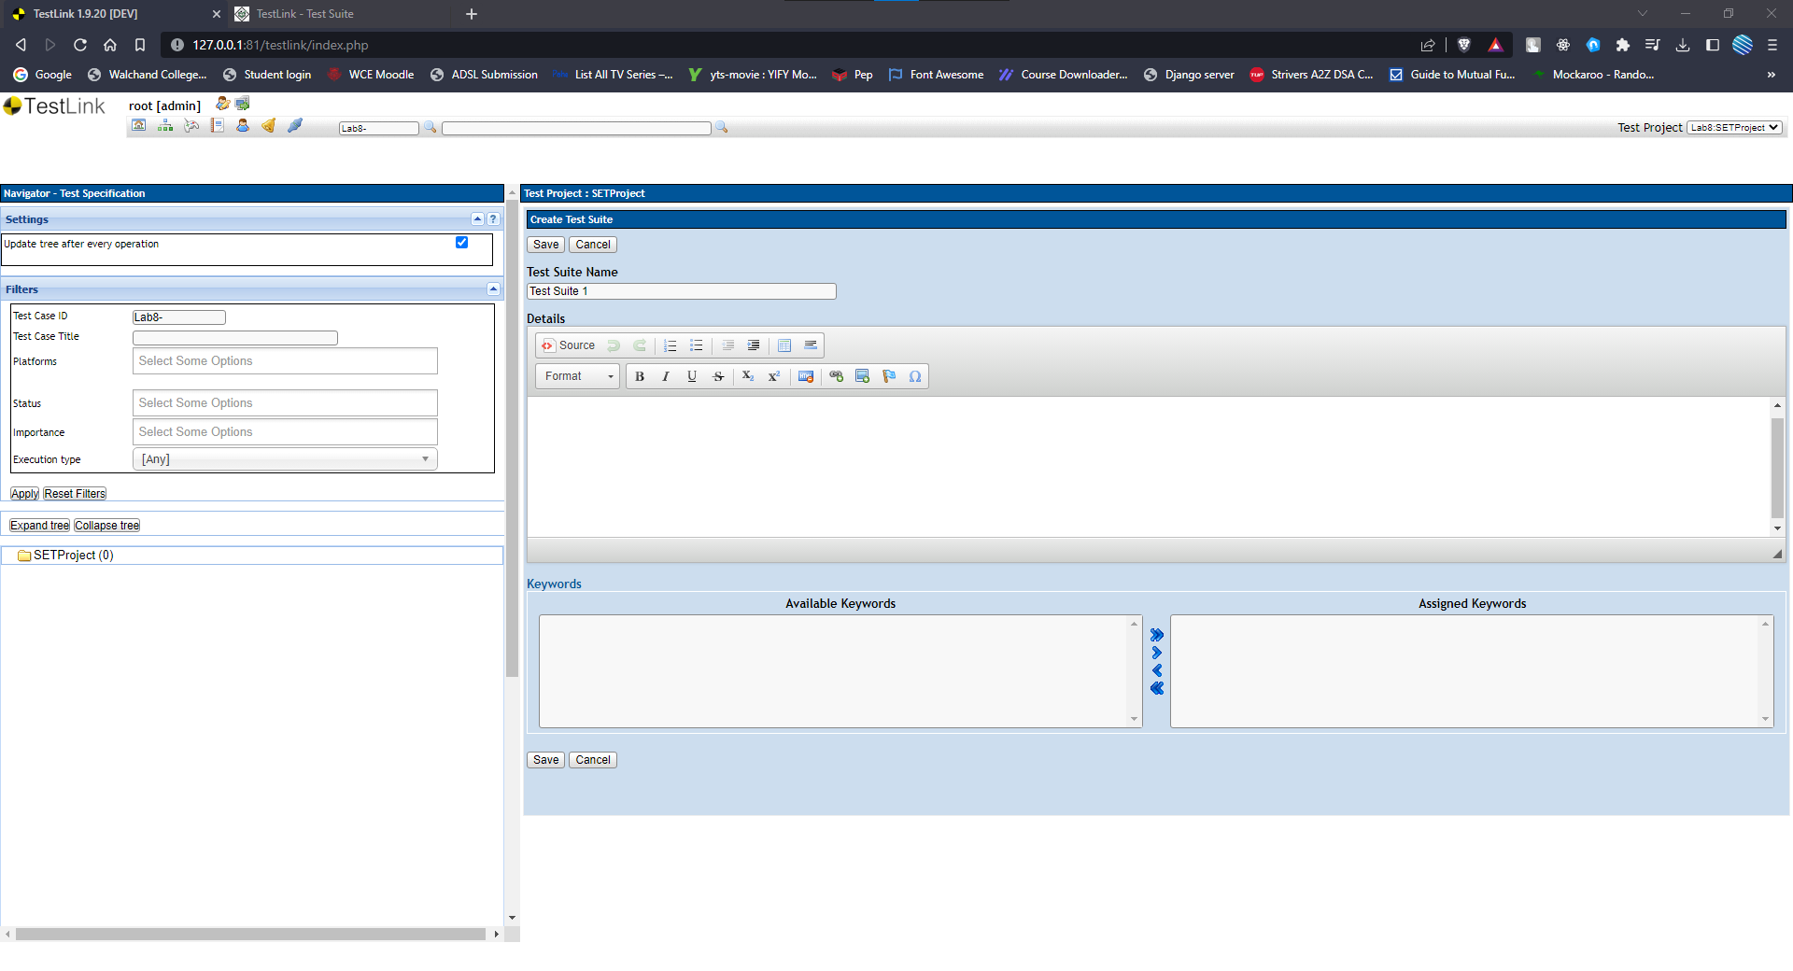

1. Create Test cases in TestLink Tool

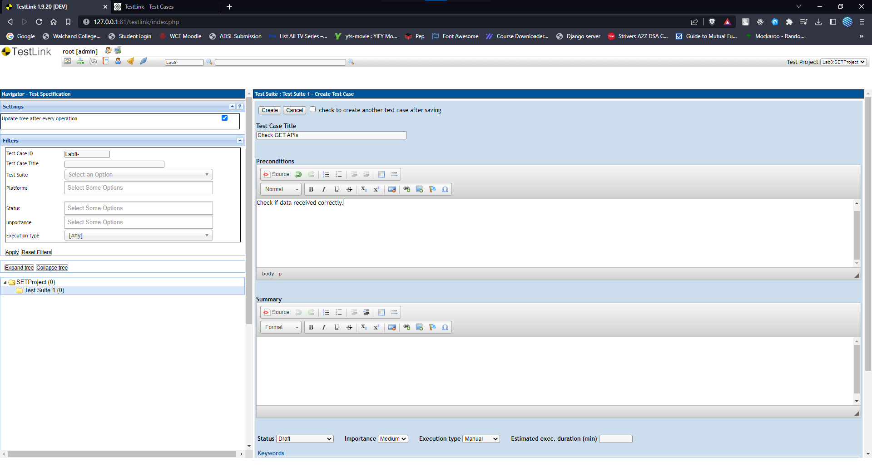

1. Assign created Test Cases to the test plan SETProjectTestPlan

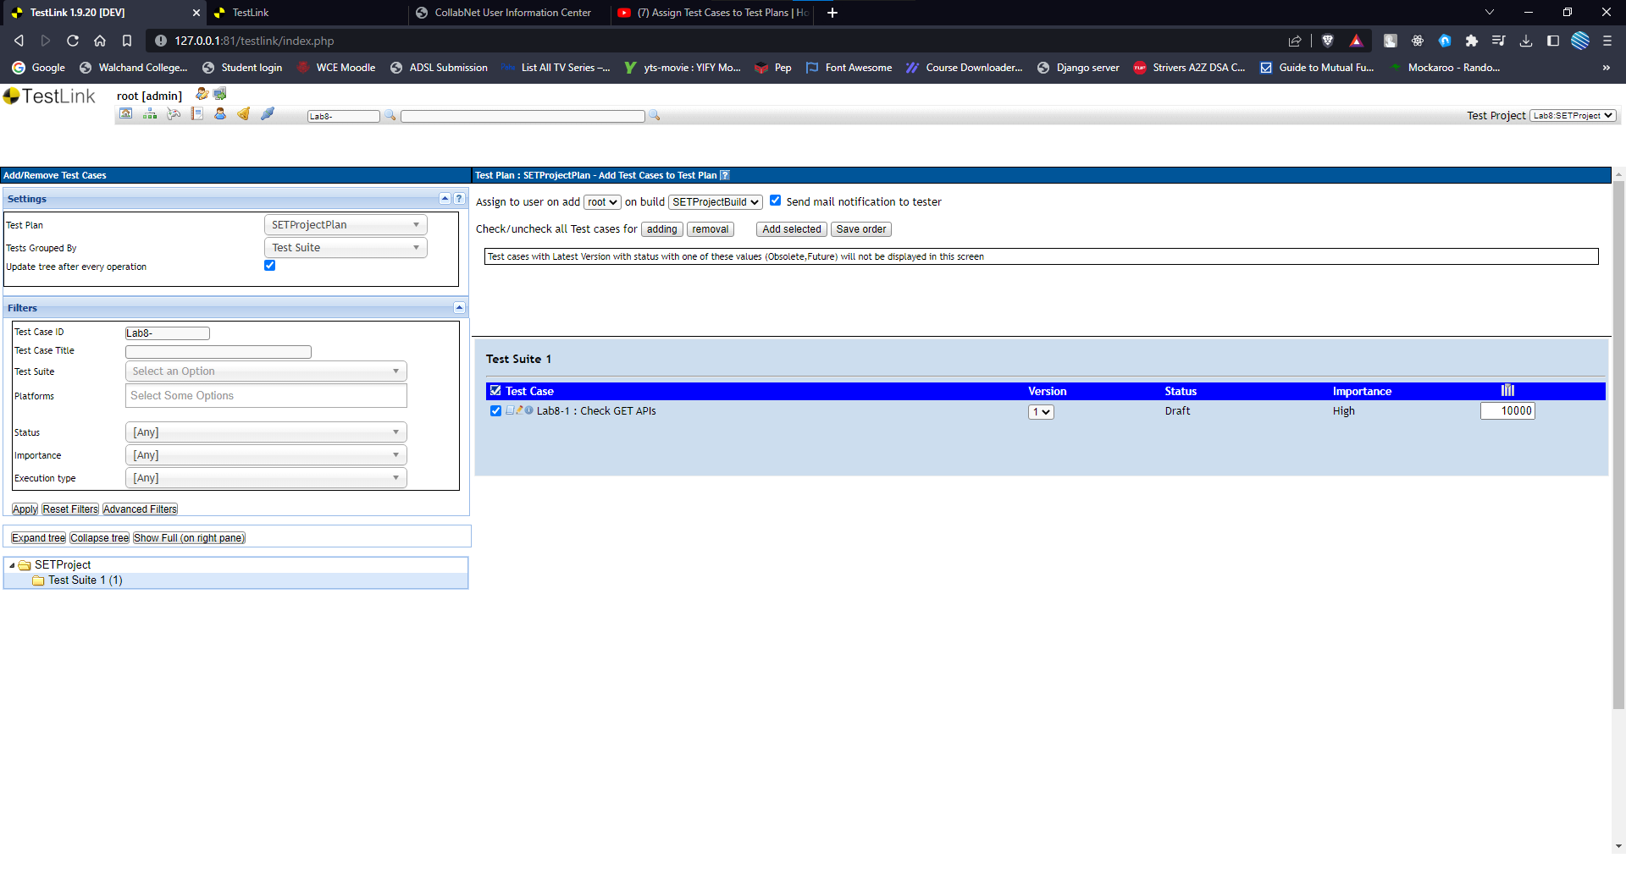

1. Create different roles as given below in the TestLink

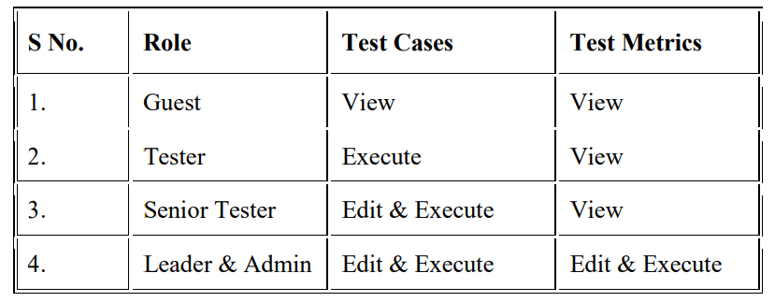

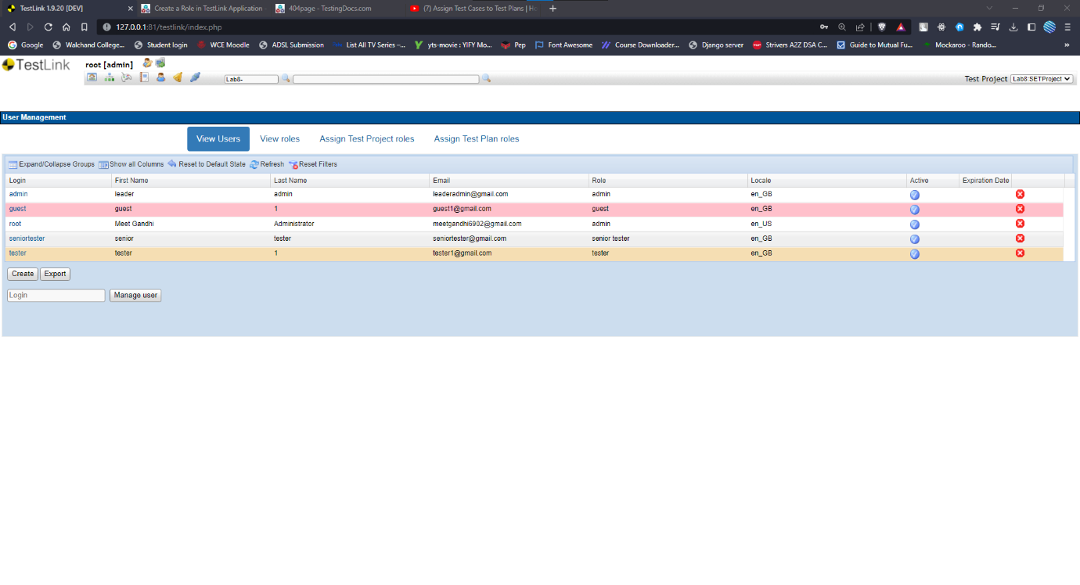

1. Write a requirements in TestLink
2. Execute test cases

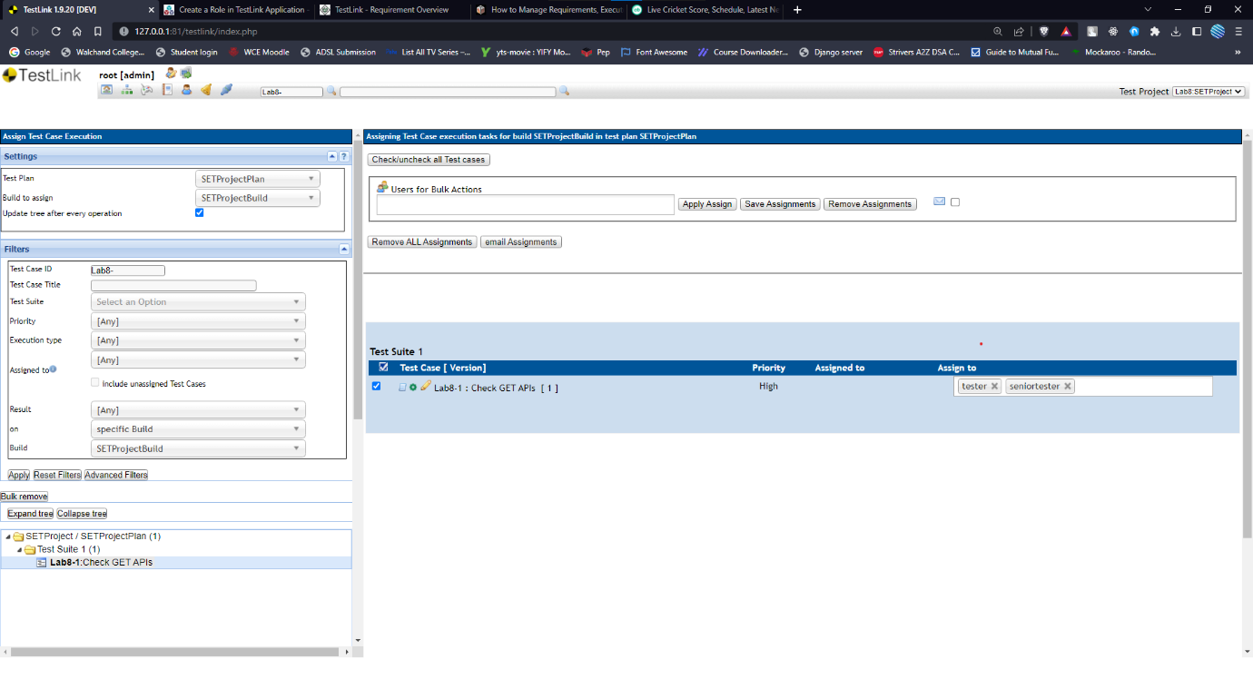

1. Generate a test report in excel format.

